3P Technik

CBB Compact Booster Set

Installation and Operation Manual
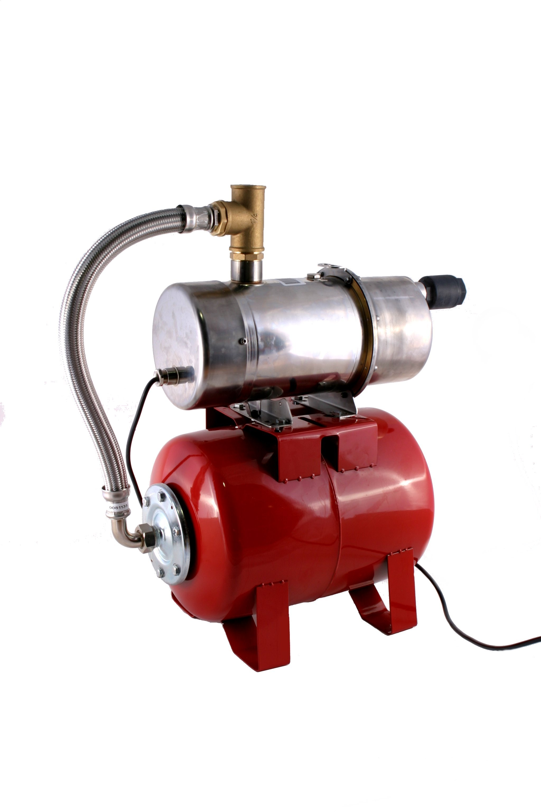

Table of Contents
Product Description 2
Installation 2
Safety 2
Electrical Wiring 3
Installation Constraints 3
Testing/Commissioning 4
Operation 5
Maintenance 6
Troubleshooting 6
Technical Specifications 7

Product Description
CBB Compact Booster Pump Sets deliver water under pressure using a water cooled automatic pump and 24L pressure vessel to reduce run-time and increase efficiency.

This Pump Set uses single point pressure control fully integrated into the pump itself, producing a simple and rugged overall design, capable of running even during total immersion such as flooding, although long term or regular immersion should avoided to prevent premature corrosion of the pressure vessel.

The pump used in this set is water cooled, with very low noise and vibration, and no requirement for ventilation.

An optional carrying handle can be attached, allowing the set to be easily moved for transportation or portable use.

Installation

Safety
Mains Voltage – There are exposed electrical conductors inside the pump. This product must be installed and serviced by a competent electrical technician to the current requirements of BS7671 and IEEE recommendations. Before servicing this appliance, normal safe isolation procedures should be implemented.

Do not touch the PCB while energised, it carries mains voltage.
Do not touch any connection terminals while energised.

Do not attempt to service electrical objects when wet, or in a wet or high humidity environment.

If the product itself or any cabling becomes damaged, you must shut down and securely isolate immediately.

You must connect this appliance to a grounded 3 wire supply, protected by suitable overload protection.

If the power cable is damaged, shut down and isolate this appliance.

Before servicing the pump, refer to the Manufacturer for advice.

Electrical Wiring
The pump must be safely isolated from the power supply before servicing. Only qualified staff should be present during servicing.

All locally applicable safety procedures and regulations must be complied with. IF IN ANY DOUBT CONSULT A QUALIFIED PROFESSIONAL.

The electrical supply is recommended to be on a dedicated circuit, with appropriate electrical protection.

Before activating the pump, please verify:
- Supply voltage and frequency
- Voltage drop/Line impedance are suitable for the current (amps) of the pump. Voltage at the pump during operation should be within 4% of the pumps stated operating voltage.
- Earth (cpc) has continuity and sufficient capacity for safe operation.
- The presence and correct operation of appropriate over-current and residual current circuit protective devices.

The pump may be temporarily halted by built-in thermal protection or protective software features, and is liable to restart without warning. Do not attempt maintenance without first proving the pump is safely isolated form the electrical supply.

Installation Constraints
Do not install this product in a location where it is likely to freeze. Freezing will damage the pump and pressure vessel. The minimum operating temperature is 2^{O}c.

Avoid installing this product where it will be in direct sunlight or temperatures above 37^{O}c.

Only install this product for the purpose of pumping clean cold water with very few suspended solids (if any). Mains water and filtered rainwater, springwater and borehole water are suitable.

Do not pump salt water, seawater, heavy chlorinated water such as pool water, or anything other than water.

Oil, petrol, diesel, kerosene, paraffin, etc will destroy the pump very quickly. You cannot use this as a fuel pump.

Install the product on it’s base, as close as possible to the source of the water, checking that inlet and outlet are clear of debris.

Incoming and out-going pipework must be appropriately supported. Vibrations or loading should be avoided.

Check that all suction pipes are clean of debris, and of a pipe or hose diameter at least that of the pump inlet. Double check that there are no leaks, and ensure that the non-return valve supplied is fitted directly to the inlet of the pump.

Testing/Commissioning
Using a pressure gauge verify the correct pre-charge pressure is present in the pressure vessel. This step is more important if the product has been in storage or has been installed for a long time before commissioning.

Fill the pump completely with water via the priming plug (the uppermost removable plug). For CBB9031B, CBB9031PRO, CBB9052B and CBB9052B/PRO models wait 1 minute after filling for the water to settle and top-up again.

Ensure that the inlet pipework is correctly connected and verify that the non-return valve is fitted directly to the pump inlet.

Check that the discharge pipe rises 50cm or more vertically to allow proper flow from the pump outlet.

Automatic pumps may initially stop due to dry run protection, particularly where water is being drawn by suction from a lower level. In this case it may be necessary to restart the pump several times until all residual air is cleared.
Any check valve or tap in the discharge pipe must be at least 2.5 metres from the pump outlet.

Do not allow the pump to run for more than 3 minutes without flow. If the pump becomes overheated (noticeably hot) switch off the electrical supply to the pump and allow to cool to room temperature before restarting.

Once operating correctly, the automatic function should be checked for correct shut-off operation by closing all outlets at the point of use (taps closed, other appliances, cisterns and header tanks full). The pump should now stop within 1 minute and remain off. If it does not then check for leaks in pipework and joints, and also faulty float valves (ball cocks) and other isolating valves. Note that if the pump continues to run without delivering water, overheating and damage will eventually occur.
The non return valve supplied with the pump must be installed on the pump inlet.

The total rise of the discharge pipe must be within 10 metres high.

If pumping water to a storage tank use a high flow diaphragm type float valve. This will help ensure the pump is moving enough water to cool itself.

Operation
Upon first switching on the booster pump system, the pump will begin to run, performing the following basic cycle, monitoring both pressure and flow rate internally.
- If pressure drops to 1.5bar or less the pump starts
- When the flow sensor stops the pump will stop
- Every 72 hours the pump momentarily starts to minimise the possibility of blockage
By following this cycle the pump will supply water whenever an outlet requires water. The following exceptions apply.
- If the flow sensor stops while pressure is low a dry run protection cycle will start involving restart attempts at increasingly long intervals starting at 15 minutes until normal operation is restored.
- If the pump restarts 40 times in 27 minutes it will assume there is a leak and shut down.

During normal operation the pump should not become noticeably warm. If this occurs you should consult the troubleshooting guide.

Maintenance
Do not undertake maintenance on the pump without first safely isolating it from the electrical supply.
During periods of prolonged inactivity, isolate the electrical supply to the pump and drain the pump body of via the drain plugs.

The pre-charge pressure in the pressure vessel is 1.5 bar and should be checked periodically. We recommend checking this every 6 months. Isolate the electrical supply, release pressure in the discharge line, and test at the valve underneath the black plastic end cap on the pressure vessel. This should be recharged with nitrogen.

The non-return valve may be removed and rinsed in order to clear any dirt that may be present.

Single phase pumps contain a capacitor which may eventually need replacement. Testing and replacement of the capacitor should be undertaken by a SteelPumps Approved Technician.

All SteelPumps are fully repairable. Contact your retailer or local stockist, or www.steelpumps.co.uk for assistance.

Troubleshooting
Problem | Possible Causes | Solutions
Pump has reduced water flow | Suction pipe obstructed  Delivery pipe obstructed  Non return valve obstructed  Partially blocked impeller  Insufficient voltage from supply  Damage to diffuser cover due to water hammer | Clear Obstruction  Clear Obstruction  Clear Obstruction  Return for service  Check electrical supply for voltage drop (line impedance of L-N conductors) or check voltage drop calcs for cable size  Return for service, increase delivery pipe size or fit shock arrestor near pump
Pump does not run – no sound | No electrical supply  Faulty control PCB  Failed capacitor | Check electrical supply  Return for service  Return for service
Pump does not run – humming sound | Failing capacitor  Impeller blocked  Motor/Bearings seized | Return for service  Return for service  Return for service
Pump Trips RCD/GFCI | Water ingress to electrical compartment/motor  Damaged cable  Water ingress to isolator switch or junction box  RCD/GFCI too sensitive  Disconnected Neutral or CPC (GFCI) | Return for service  Return for service  Dry out junctions  Ramp or No-trip test (10mA RCD, 2mA GFCI)  Verify conductor integrity
Pump does not stop when outlet closed | Large leak on discharge hose  Pump installed is manual not automatic  Large leak from pump body (damaged flange, punctured pump body. | Pressure test  Check model (X-AJE not X-JE)  Return for service
Pump runs but does not pump water | Pump not primed (air)  Leak in suction hose  Severe blockage  Non return valve seized  Impeller failed | Prime pump and suction hose (fill with water)  Check hose, seal connections  Clear Obstruction  Replace NRV  Return for service
Pump has reduced pressure | Damaged venturi  Partially blocked impeller  Insufficient voltage from supply  Damage to diffuser cover due to water hammer | Return for service  Return for service  Check electrical supply for voltage drop (line impedance of L-N conductors) or check voltage drop calcs for cable size  Return for service, increase delivery pipe size or fit shock arrestor near pump

Technical Specifications
Model | Pump | Performance |  | Power
Model | Pump | Max Pressure  bar | Max Flow  L/min | Voltage | Current  Amps | Frequency  Hz
CBB5041P | X-AJE80P | 4.1 | 50 | ~1 230 | 4.5 | 50Hz
CBB5051P | X-AJE120P | 5.1 | 50 | ~1 230 | 6.3 | 50Hz
CBB5041B | X-AJE80B | 4.1 | 50 | ~1 230 | 4.5 | 50Hz
CBB5051B | X-AJE120B | 5.1 | 50 | ~1 230 | 6.3 | 50Hz
CBB5041PRO | X-AJE80PRO | 4.1 | 50 | ~1 230 | 4.5 | 50Hz
CBB5051PRO | X-AJE120PRO | 5.1 | 50 | ~1 230 | 6.3 | 50Hz
CBB9031B | X-AMO80B | 3.1 | 90 | ~1 230 | 5.1 | 50Hz
CBB9052B | X-AMO120B | 5.2 | 90 | ~1 230 | 7.5 | 50Hz
CBB9031PRO | X-AMO80PRO | 3.1 | 90 | ~1 230 | 5.1 | 50Hz
CBB9052PRO | X-AMO120PRO | 5.2 | 90 | ~1 230 | 7.5 | 50Hz
CBB10021B | X-A2CP | 2.1 | 100 | ~1 230 | 4.8 | 50Hz

